**CROSSWORD PUZZLE**

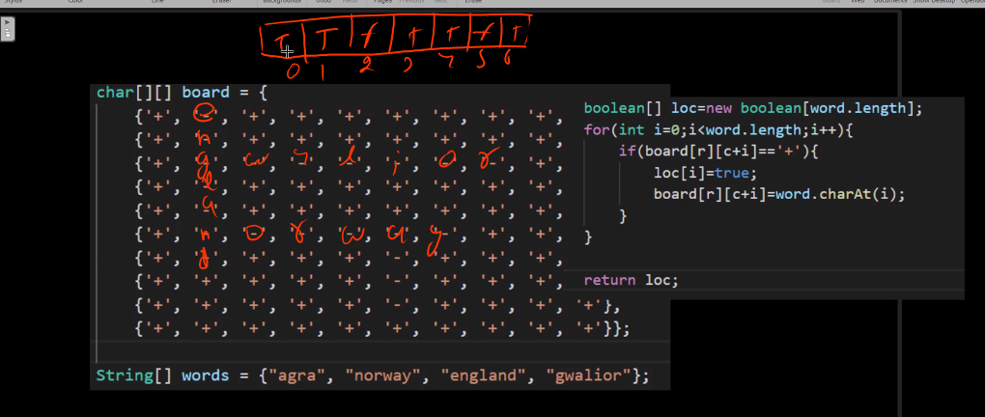

**Best case is occurred when length of all words is different**

**TREE IS NOTHING BUT A DIRECTED GRAPHH**



